**广东海洋大学学生实验报告书（学生用表）**

**GDOU-B-11-112**

|  |  |  |  |  |  |  |  |  |  |  |  |  |  |
| --- | --- | --- | --- | --- | --- | --- | --- | --- | --- | --- | --- | --- | --- |
| 实验名称 | 原生js实现轮播图 | | | | 课程名称 | | 用户界面设计 | | | | 课程号 | |  |
| 学院(系) | 数计（软件）学院 | | 专业 | 软件工程 | | | | | 班级 | | 软件1172 | | |
| 学生姓名 | 黄国铭 | 学号 | 201711701206 | | | 实验地点 | |  | | 实验日期 | |  | |

1. 实验目的

使用原生js实验轮播的滚动 并支持上下张切换和点击切换

1. 实验内容

基本原理：讲图片排成一排 通过使用定时器 每隔一段时间移动一张图片的距离 若图片是最后一张 则移动到最开始的位置

1. html部分

<body>

<div class="swiper">

<div class="main-swiper">

<div class="main-img">

<img src="../img/1.jpg" alt="">

<img src="../img/2.jpg" alt="">

<img src="../img/3.jpg" alt="">

<img src="../img/4.jpg" alt="">

</div>

<div class="count">

<div class="count-item count-active"></div>

<div class="count-item"></div>

<div class="count-item"></div>

<div class="count-item"></div>

</div>

<div class="mini-img">

<img src="../img/1.jpg" alt="">

<img src="../img/2.jpg" alt="">

<img src="../img/3.jpg" alt="">

<img src="../img/4.jpg" alt="">

</div>

</div>

<div>

<div class="btn">

<div class="btnup"><div class="up"></div></div>

<div class="btnnext"><div class="next"></div></div>

</div>

</div>

</div>

</body>

1. css部分

body{

margin: 0;

padding: 0;

box-sizing: border-box;

}

.swiper{

width: 100vw;

height: 100%;

margin-top: 100px;

display: flex;

justify-content: center;

align-items: center;

}

.main-swiper{

width: 50%;

overflow: hidden;

position: relative;

}

.main-img{

width: 100%;

display: flex;

transition: 1s;

}

.main-img img{

width: 100%;

object-fit: cover;

}

.count{

display: flex;

justify-content: center;

position: relative;

bottom: 20px;

}

.count-item{

width: 10px;

height: 10px;

margin: 5px;

background-color: #fff;

border-radius: 100%;

}

.count-active{

background-color: red;

}

.mini-img{

width: 100%;

display: flex;

overflow-y: hidden;

position: relative;

}

.mini-img img{

width: 25%;

}

.mini-img::-webkit-scrollbar{

display: none;

}

.btnup{

width: 8%;

height: 96%;

position: absolute;

top: 0;

left: 210px;

}

.btnnext{

width: 10%;

height: 96%;

position: absolute;

top: 0;

right: 150px;

}

.up{

width: 0;

height: 0;

border: 15px solid transparent;

border-right: 15px solid #000;

position: relative;

top: 50%;

}

.next{

width: 0;

height: 0;

border: 15px solid transparent;

border-left: 15px solid #000;

position: relative;

top: 50%;

left: 25px;

}

1. js部分

let mainSwiper = document.getElementsByClassName("main-img")[0];

let countItem = document.getElementsByClassName("count-item")

//轮播图片个数

let totalImg = document.getElementsByTagName("img");

let imgCount = totalImg.length/2;

let swiperStyle = mainSwiper.style;

let swiperWidth = mainSwiper.clientWidth;

let swiperTransDistance = 0;

let currentIndex = 0

let upBtn = document.getElementsByClassName("up")[0];

let nextBtn = document.getElementsByClassName("next")[0];

console.log(imgCount);

//设置定时器

let timer = setInterval(() => {

imgTranslate();

countTrans();

}, 3000);

//开启定时器

function startTimer(){

timer = setInterval(()=>{

imgTranslate();

countTrans();

}, 3000);

}

//关闭定时器

function stopTimer(){

clearInterval(timer);

}

//图片轮播动画

function imgTranslate(){

if(currentIndex == imgCount-1){

swiperStyle.transform = `translateX(0px)`;

swiperTransDistance = 0;

}else{

swiperTransDistance = swiperWidth * (currentIndex+1);

swiperStyle.transform = `translateX(-${swiperTransDistance}px)`

}

}

//图片向前滚动

function imgReTrans(){

if(currentIndex!=0){

swiperStyle.transform = `translateX(-${swiperWidth * (currentIndex-1)}px)`;

}else{

swiperStyle.transform = `translateX(-${swiperWidth * (imgCount-1)}px)`;

}

}

//底部指示器的滚动

function countTrans(){

console.log(currentIndex);

if(currentIndex == imgCount-1){

currentIndex = 0;

countItem[currentIndex].classList.add("count-active");

countItem[imgCount-1].classList.remove("count-active")

}else{

countItem[currentIndex].classList.remove("count-active");

countItem[currentIndex+1].classList.add("count-active");

currentIndex++;

}

}

//底部指示器向前滚动

function countReTrans(){

if(currentIndex == 0){

countItem[imgCount-1].classList.add("count-active");

countItem[currentIndex].classList.remove("count-active");

currentIndex = imgCount-1;

}else{

countItem[currentIndex].classList.remove("count-active");

countItem[currentIndex-1].classList.add("count-active");

currentIndex--;

}

}

//上一张图片

upBtn.addEventListener("click", () => {

stopTimer();

imgReTrans();

countReTrans();

startTimer();

})

//下一张图片

nextBtn.addEventListener("click", () => {

stopTimer();

imgTranslate();

countTrans();

startTimer();

})

//触摸小图切换图片

for(let i = imgCount;i<totalImg.length;i++){

totalImg[i].addEventListener("click", () => {

stopTimer();

console.log(Math.abs(currentIndex-(i-imgCount)));

let picInterval = currentIndex-(i-imgCount);

let picIntervalAbs = Math.abs(picInterval);

if(picInterval<0){

for(let a = 0;a<picIntervalAbs;a++){

console.log(a);

imgTranslate();

countTrans();

}

}else{

for(let a = 0;a<picIntervalAbs;a++){

console.log(a);

imgReTrans();

countReTrans();

}

}

startTimer();

})

}

1. 实验结果

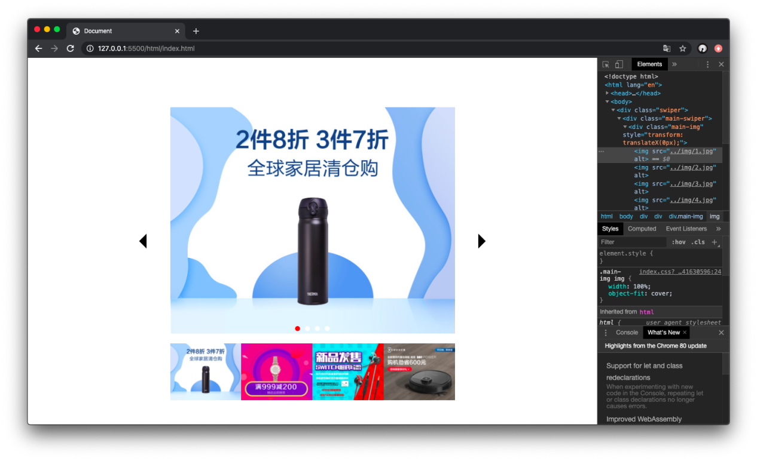 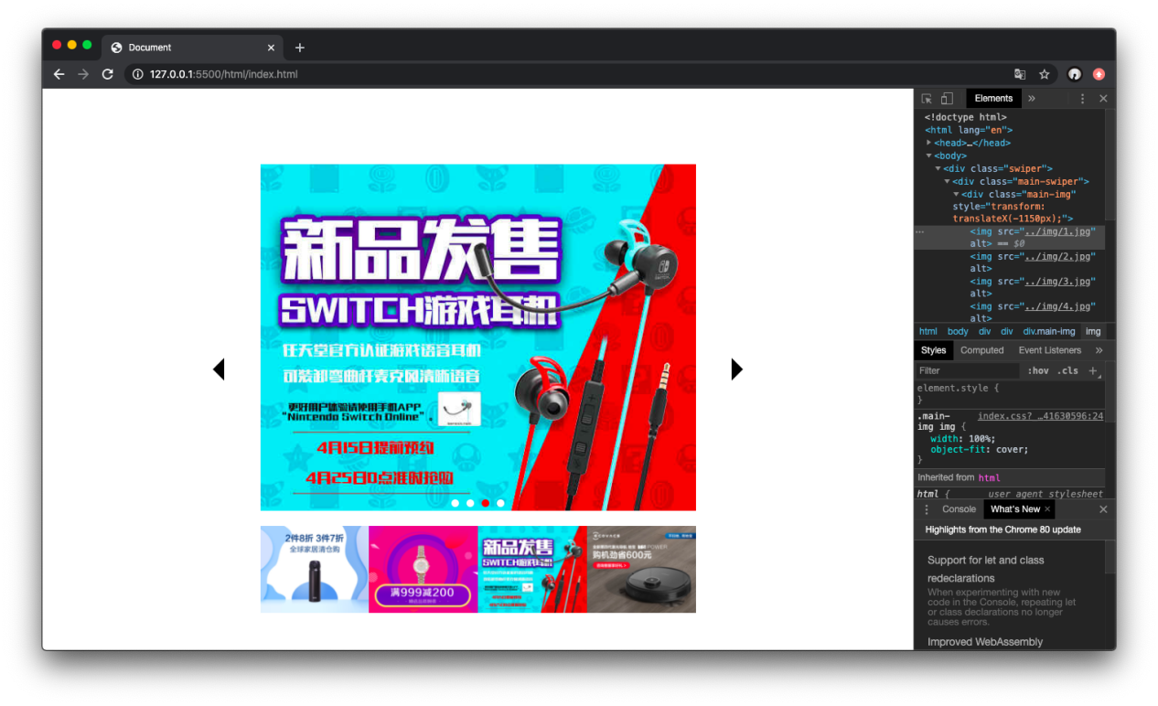

通过点击左右两个按钮可以实现图片的上下张切换

点击下方下图 也可快速切换图片

底部小红点也会跟随图片改变

并且图片滚动带有滚动动画